The Many Hats of ASTEF

Do any of you enjoy wearing hats? What kind of hats do you personally wear? What kinds of hats do you have in your home? There are all kinds of hats that people use.
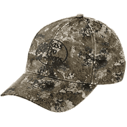
Do you have any hunters or fishermen hats in your home? There are certainly hats associated with these activities.
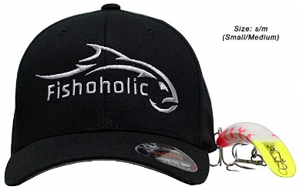
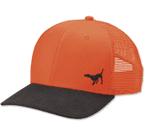

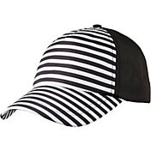
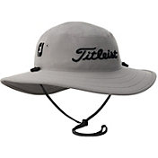
What about golf hats? Anybody have golf hats at home?
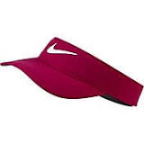

Hats can protect you from the sun. Do you ever wear a sun hat at the beach?
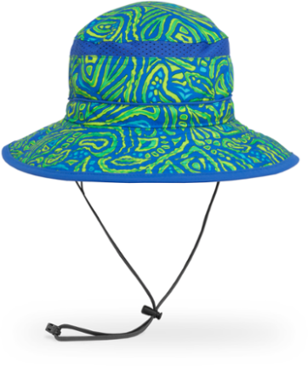
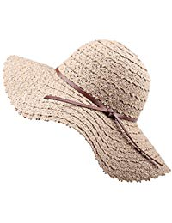
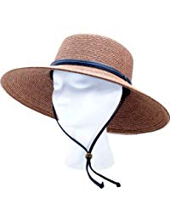

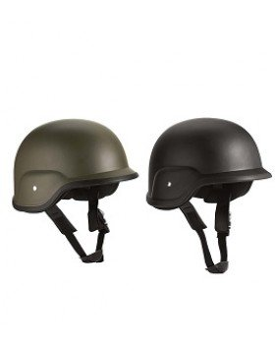
Hats can be a symbol of authority. Military and law enforcement officers all wear hats.
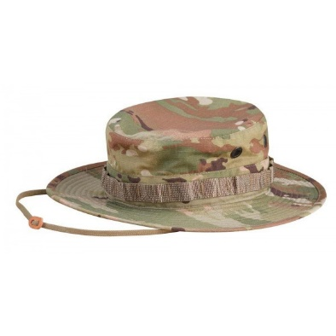
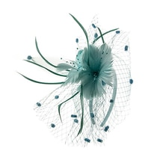
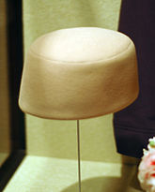
Hats can be a form of art. Jackie O’s pillbox hats to British fascinators are beautiful to see.
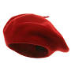

Building on the idea of hats, ASTEF…The Alpha State Texas Educational Foundation…wants to take a little time to remind you of the many different hats worn by ASTEF and the work that YOUR FOUNDATION is involved in.
ASTEF wears hats…several different kinds of hats. For example… (pull out a hard hat)

A hard hat symbolizes workers and the members of ASTEF are hard workers!
- ASTEF is a committed foundation that provides funding for numerous projects going on all over the state of Texas. Project stipends are given to DKG chapters, coordinating councils, areas, and individual members in Texas for projects that support and promote the professional and personal growth of women educators in Texas as well as educational excellence for Texas students.
- This past year, ASTEF presented checks to 22 Texas chapters totaling over $38,000. We are proud to support these chapters in the work they do for Texas teachers and students.
Another hat worn by members of ASTEF is a mortar board.

This is easy…think Scholarship. ASTEF funds all scholarships presented by the Texas State Organization.
At the Waco convention, TSO announced:
- $18,000 in scholarships for advanced degrees
- $20,000 in Lifelong Learner Travel Scholarships
- Almost $5,000 in Mini-grants for professional development activities
Not to be forgotten…our Aspiring Educators. ASTEF provides grants to women in Texas to assist them in completing a bachelor’s degree in education and/or (took out a) Texas teacher certification. Do you know someone who might qualify? $10,000 has been set aside to support Aspiring Educators in Texas.
A 3rd hat worn by members of ASTEF…a Top Hat!

This may be a little more difficult…what does a top hat signify? Think…Fancy, Winners, Elegant, Presidential, Distinguished, Stately, Leaders…Ohhh, I get it…The top hat signifies Leadership!
ASTEF provides the funding for the Leadership Seminar Training for 30 Texas women held in February of odd numbered years. This intense weekend seminar supplements and enhances leadership, communication and management skills of DKG members in Texas.
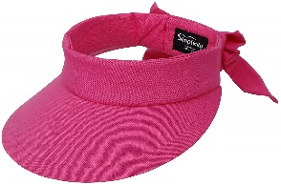
We have one more ASTEF hat to share with you. What do you think this visor hat is for…hmmm?
I know…ASTEF Travel Opportunities!
Williamsburg, Virginia, Savannah, Georgia, Galveston, Fredericksburg, Ashville, North Carolina and the Smoky Mountains, Brenham & College Station to name a few
Weekender trips…longer Road Scholar Trips are some of the trips offered
What are you interested in…what suits you best? We have something for you! Check out www.astef.org regularly for information about upcoming ASTEF travel opportunities.
Possible conclusion:
We encourage you to be proud of your ASTEF membership! ASTEF is hard working and supportive of its members. Each of you is a member of The Alpha State Educational Foundation and as such, we thank you for all the support you provide. We couldn’t do it without you!

Alternate conclusion:
We encourage you to be proud of your ASTEF membership! ASTEF is hard working and supportive of its members. Each of you is a member of The Alpha State Educational Foundation and as such, we thank you for the support you provide.
As a result…We pull one more item from our bag…not a hat…an apron. (Pull out a builder’s apron with play money.)
We cannot let this opportunity go by without “passing the hat” and asking for your donations. (Pass around the top hat.) Your financial assistance is vital to help us support the mission of ASTEF and TSO. We appreciate every dollar we take in and we use it to the best of our abilities because we know YOU are investing in YOUR foundation. We couldn’t do it without you!

